**“DUAL AXIS ROTATING SOLAR PANEL”**

A PROJECT REPORT

Submitted in partial fulfillment of the requirements for the award of the degree



**Bachelor of Technology**

**In**

**Electronics & Communication Engineering**

**From UPTU**

**By**

**Ramkrit chauhan (1122331044)**

**Indrajeet Kumar (1122331017)**

**Pushpendra Kumar (1122331038)**

**Rahul Kumar (1122331039)**

**Under the Guidance of**

**MR.sanjay yadav**

**(Asst. Professor)**

**Department of Electronics & Communication Engineering**

**Vivekanand Institute of Technology & Science, Ghaziabad**

**2014-15**

***CERTIFICATE***

Certified that have carried out the projectwork presented in this report entitled **“Dual Axis rotating solar panel”** for the award of Bachelor of Technology from Uttar PradeshTechnical University, Lucknow under my supervision. The report embodies results of original work, and studies are carried out by the student himself and the contents of the report do not form the basis for the award of any other degree to the candidate from this Institution.

1. Ramkrit chauhan
2. Indrajeet Kumar
3. Pushpendra Kumar
4. Rahul Kumar

PROJECT GUIDE Mr. Amit Singhal

Mr.sanjay yadav (Head of Department)

(Assistant Professor)

DATE:

PLACE:

***ACKNOWLEDGEMENT***

I would like to express my gratitude to **Mr. Sanjay yadav**, Astt. Prof.ECE, vits for guidance and support throughout this project work. He has beena constant source of inspiration to me throughout the period of this work. Iconsider myself extremely fortunate for having the opportunity to learn and workunder his supervision over the entire period. I would also take this opportunity to express my gratitude and sincerethanks to **Mr. Ajit ranaut,** Asstt. Prof. ECE, Vits for his valuablesupport.

I would like to thank all faculty members and staff of the Department of Electronics and Communication Engineering, VITS, GHAZIABAD for their generous help in various ways for the completion of this thesis.

I would like to thank all my friends and especially my classmates for all the thoughtful and mind stimulating discussions we had, which prompted us to think beyond the obvious. I’ve enjoyed their companionship so much during my stay at VITS, GHAZIABAD.

I am especially indebted to my parents for their love, sacrifice, and support. They are my first teachers after I came to this world and have set great examples for me about how to live, study, and work.

**Ramkrit chauhan (1122331044) Indrajeet Kumar (1122331017)**

**Pushpendra Kumar (1122331038)**

**Rahul Kumar (1122331039)**

***ABSTRACT***

The recent decades have seen the increase in demand for reliable and clean form of electricity derived from renewable energy sources. One such example is solar power. The challenge remains to maximize the capture of the rays from the sun for conversion into electricity. This paper presents fabrication and installation of a solar panel mount with a dual-axis solar tracking controller. This is done so that rays from the sun fall per- pendicularly unto the solar panels to maximize the capture of the rays by pointing the solar panels towards the sun and following its path across the sky. Thus electricity and efficiency increased.

iii.

**TABLE OF CONTENTS**

**CHAPTER NO.TITLE** **PAGE NO.**

*CERTIFICATE*.............................................................................................................i

*ACKNOWLEDGEMENT* ...........................................................................................ii

*ABSTRACT* ................................................................................................................iii

*TABLE OF CONTENTS*............................................................................................iv

*ABBREVIATIONS* .....................................................................................................v

**CHAPTER 1 INTRODUCTION** ....................................................................**7**

1.1 DISCRIPTION...............................................................................................................*7*

1.2 SOLAR POWER IN INDIA ........................................................................................ 9

1.3 LITERATURE REVIEW ............................................................................................ 11

1.4 AIM OF THE PROJECT.............................................................................................. *13*

iv

**CHAPTER 2 SOLAR RADIATIONS& PHOTOVOLTAIC**…………..…14

2.1 CONCEPTS ON SOLAR RADIATION……………………………………………....14

2.2 INSOLATION .....................................................................................................17

2.3 PROJECTION EFFECT .......................................................................................17

2.4WORKING OF PHOTOVOLTAICS ...............................................................................18

**CHAPTER 3 SOLATRACKER**……………………………………………20

3.1 INTRODUCTION ….........................................................................................20

3.2 NEED FOR SOLAR TRACKER ......................................................................20

3.3 TYPES OF SOLAR TRACKERS .....................................................................22

**CHAPTER 4 DESIGN OF SOLAR TRACKER**…....................................25

4.1 TRACKER DESIGN ....................................................................................... 25

4.2 DC MOTOR AND MOTOR DRIVER THEORY ............................................26

4.3 SYSTEM DESIGN……………………………………………...……………….32

4.4 SENSORS…………………………………………………………………...…...33

4.5 MICRO CONTROLLER………………………………………………………...35

4.6 ARDUINO SEVERINO BOARD…………………………………………...…..38

**CHAPTER 5 PROGRAME** ............................................................................42

5.1 Conclusion……………………………………………………..……….…42

5.2 REFERENCES*………………………………………..…………..* .................................*43*

v

**LIST OF FIGURES**

**S.NO. TITLE PAGE NO.**

1. Sensor response once a shadow is cast on one LDR 04
2. Sun path diagram for miri,Sarawak,Malaysia 04
3. Passive tracking system 18
4. Dual axis solar tracker 20
5. Setup of a squared solar panel 21
6. Inner working of a DC motor 22
7. DC servomotors 24
8. Configuration and angle of panel-zenith angle of the sun 27
9. Block diagram of overall system 28
10. Sensor 29
11. Microcontroller 31
12. Arduino serverino board 35
13. My final project 36

vi

**ABBREVIATIONS**

PV Photovoltaic

DOF Degree of Freedom

PV Panels Photovoltaic panels

MPPT Maximum Power Point

SCM Single-chip microcomputer

DC Direct current

HSAT Horizontal single axis track

VSAT Vertical single axis trackers

AADAT Azimuth-Altitude dual axis trackers

MOU Memorandum of understanding

vii.

***CHAPTER- 1***

**INTRODUCTION**

Electrical energy from solar panels is derived by converting energy from the rays of the sun into electrical current in the solar cells. The main challenge is to maximize the capture of the rays of the sun upon the solar panels, which in turn maximizes the output of electricity. A practical way of achieving this is by positioning the panels such that the rays of the sun fall perpendicularly on the solar panels by tracking the movement of the sun [1]. This can be achieved by means of using a solar panel mount which tracks the movement of the sun throughout the day. Energy conversion is most efficient when the rays fall perpendicularly onto the solar panels. Thus, the work is divided into three main parts namely the mounting system, the tracking controller system and the electrical power system. In solar tracking systems, solar panels are mounted on a structure which moves to track the movement of the sun throughout the day. There are three methods of tracking: active, passive and chronological tracking. These methods can then be configured either as single-axis or dual-axis solar trackers. In active tracking, the position of the sun in the sky during the day is continuously determined by sensors. The sensors will trigger the motor or actuator to move the mounting system so that the solar panels will always face the sun throughout the day. This method of sun-tracking is reasonably accurate except on very cloudy days when it is hard for the sensor to determine the position of the sun in the sky thus make

Passive Tracking unlike active tracking which deter- mines the position of the sun in the sky, a passive tracker moves in response to an imbalance in pressure between two points at both ends of the tracker. The imbalance is caused by solar heat creating gas pressure on a “low boiling point compressed gas fluid that is driven to one side or the other” [2] which then moves the structure. How- ever, this method of sun-tracking is not accurate. A chronological tracker is a timer-based tracking system whereby the structure is moved at a fixed rate throughout the day. The theory behind this is that the sun moves across the sky at a fixed rate. Thus the motor or actuator is

Programmed to continuously rotate at a “slow average rate of one revolution per day (15 degrees per hour)” [2]. This method of sun-tracking is very accurate. However, the continuous rotation of the motor or actuator means more power consumption and tracking the sun on a very cloudy day is unnecessary. A single-axis solar tracker follows the movement of the sun from east to west by rotating the structure along the vertical axis. The solar panels are usually tilted at a fixed angle corresponding to the latitude of the location. According to [3], the use of single-axis tracking can in- crease the electricity yield by as much as 27 to 32 per- cent. On the other hand, a dual-axis solar tracker follows the angular height position of the sun in the sky in addition to following the sun’s east-west movement [3] re- ports that dual-axis tracking increases the electricity output as much as 35 to 40 percent.

1.1 Description

The primary task of this pilot project is to build an actual solar panel mount with a sun-tracking system to be in- stalled outdoors in Miri (location: 4˚23′35″N 113˚58′49″E) in Sarawak, Malaysia. Based on the background information of the various types of solar trackers, it has been decided that active tracking with a dual-axis set-up will be used. The reason for this choice is active tracking is a fairly effective method to track the sun and a dual-axis tracking system has the capability of increasing the yield of electrical energy output from the solar panels. For the purpose of clarity, the east-west of the tracker will be called the “horizontal tracking” while the angular height tracker will be referred to as “vertical tracking”. An active, dual-axis tracking system prototype has al- ready been designed and built by [4], which consists of the sensor system to determine the position of the sun and a control system which reads data from the sensors to command the movement of the tracker. A program to control the tracking system has been also developed [4]. The sensor system consists of two sensors: one to deter- mine the position of the sun in the sky and another to determine the position of the sun’s movement from east to west. Each sensor consists of two Cadmium Sulphate (CdS) light dependent resistors (LDRs). The LDRs were placed as shown in Figure 1, a shadow will fall on one of the LDRs when the sensor is not pointing directly toward the sun resulting in difference of the level of resistance between the two LDRs. This difference will be detected by the microchip in the control system and will move the tracker accordingly so that both LDRs are pointing towards the sun. To decide how the tracker would move, it is important to consider the movement of the sun in the sky through- out the year. The sun path diagram of Figure 2 shows the annual variation of the path of the sun in Miri. From the sun path diagram, the movement of the sun

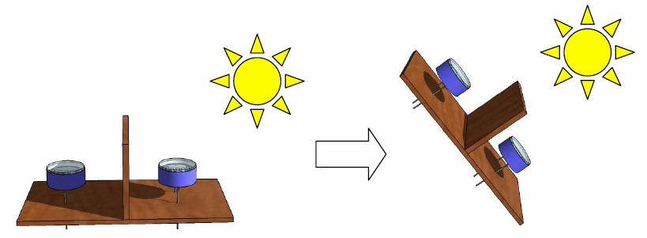

**Figure 1. Sensor response once a shadow is cast on one LDR.**





**Figure 2. Sun path diagram for Miri, Sarawak, Malaysia.**

**1.2SOLAR POWER IN INDIA**

In July 2009, India unveiled a US$19 billion plan to produce 20 GW (20,000MW) of solar power by 2020. Under the plan, the use of solar-powered

Equipment and applications would be made compulsory in all government buildings, as well as hospitals and hotels. On November 18, 2009, it was reported

That India was ready to launch its National Solar Mission under the National Action Plan on Climate Change, with plans to generate 1,000 MW of power by2013. India's largest photovoltaic (PV) power plants

1.Reliance Power Pokaran Solar PV Plant, Rajasthan, 40MW 02011-06June 2011 Commissioning in March 2012

2.AdaniBitta Solar Plant, Gujarat, 40MW 02011-06 June 2011 To be Completed December 2011

3.Moser Baer - Patan, Gujarat, 30MW02011-06 June 2011 Commissioned July 2011

4.Azure Power - Sabarkantha, Gujarat, 10MW 02011-06 June 2011 Commissioned June 2011

5.Green Infra Solar Energy Limited - Rajkot, Gujarat, 10M W 02011-1129November29, 2011CommissionedNovember2011

The average solar radiations receiver by different regions in India. The daily average solar energy incident over India varies from 4 to 7 kWh/mwith about 1500–2000 sunshine hours per year (depending upon location), which is .far more than current total energy consumption. For example, assuming the efficiency of PV modules were as low as 10%, this would still be thousand times greater than the domestic electricity demand projected for 2015.shows the average solar radiations receiver by different regions in India.

Gujarat government has signed a MoU with Clinton Foundation to build the world’s largest solar-power plant in the region. The 3,000-megawatt plant near the border between India and Pakistan would be one of four planned by the initiative, a William J. Clinton Foundation program to promote renewable energy. The other proposed sites are in California, South Africa, and Australia.

**1.3LITERATURE REVIEW**

Sun-synchronous navigation is related to moving the solar powered rover(robot) in such a way that its solar panel always points toward the sun and which results into maximum battery charging and hence the rover can work for long hours. The unique feature of this solar tracking system is that instead of taking the earth as its reference, it takes the sun as a guiding source. Its active sensors constantly monitor the sunlight and rotate the panel towards the direction where the intensity of sunlight is maximum. The light dependent resistor’s do the job of sensing the change in the position of the Sun. The control circuit does the job of fetching the input from the sensor and gives command to the motor to run in order to tackle the change in the position of the sun. By using this system the additionalenergy generated is around 25% to 30% with very less consumption by the system itself. The paper gives the design and implementation of a fuzzy logic computer controlled sun tracking system to enhance the power output of photo voltaic solar panels. The tracking system was driven by two permanent magnet DC motors toprovide motion of the PV panels in two axis. The project describes the use of microcontroller based design methodology of an automatic solar tracker. Light dependent resistors are used as the sensors of the solar tracker. The tracking system maximizes solar cell output by positioning a solar panel atthe point of maximum light intensity**.** This paper describe the use of DC motors, special motors like stepper motors, servo motors, real time actuators, to operate moving parts of the solar tracker. The system was designed as the normal line of solar cell always move parallel to the rays of the sun. The Aim of this project is to develop and implements a prototype of two-axis solar tracking system based on microcontroller. The parabolic reflector or parabolic dish is constructed around two feed diameter to capture the sun’s energy. The focus of the parabolic reflector is pointed to a small area to get extremely high temperature. The temperature at the focus of the parabolic reflector is measured with temperature probes. This auto-tracking system is controlled with two 12V, 6W DC gear box motors. The five light sensors (LDR) are used to track the sun and to start the operation (Day/Night operation). The paper adopts the PWM DC motor controller. It is capable of archiving the timeliness, reliability and stability of motor speed control, which is difficult to implement in traditional analog controller. The project concentrates on the design and control of dual axis orientation system for the photovoltaic solar panels. The orientation system calculations are based on astronomical data and the system is assumed to be valid for any region with small modifications. The system is designed to control the Altitude angle in the vertical plane as well as the Azimuth angle in the horizontal plane of the photovoltaic

Panel workspace. And this system is expected to save more than 40% of the totalenergy of the panels by keeping the panel’s face perpendicular to the sun. In theprevious solutions, each tracking direction is controlled by using a Sun sensor made by a pair of phototransistors. The single matrix Sun sensor (MSS) controls both axes of the tracking system. The inspiration for the MSS is the antique solarclock. MSS comprises 8 photo resistors and a cylinder the differencebetween a shaded photo resistor cell and a lighted cell is recognized using an electronic circuit and corresponding output voltage signals are given to the DC motorswhich will move the array toward sun. In order to improve the solar tracking accuracy, the author comes up with combining program control and sensor control. Program control includes calendar-check tracking and the local longitude, latitude and time, to calculate thesolar altitude and solar azimuth by SCM (single-chip microcomputer), servomotor is used to adjust the attitude of the solar panel. Sensor control is that a sunray detected by photoelectric detector and then the changed signal is transmitted tocontrol step motor to adjust the attitude of the solar. The paper discusses thetechnology options, their current status and opportunities and challenges indeveloping solar thermal power plants in the context of India. The National SolarMission is a major initiative of the Government of India and State Governments to promote ecologically sustainable growth while addressing India’s energysecurity challenge. It will also constitute a major contribution by India to theglobal effort to meet the challenges of climate change.

**1.4 AIM OF THE PROJECT**

The aim of the project is to keep the solar photovoltaic panelperpendicular to the sun throughout the year in order to make it more efficient.The dual axis solar photovoltaic panel takes astronomical data as reference andthe tracking system has the capability to always point the solar array toward thesun and can be installed in various regions with minor modifications. The verticaland horizontal motion of the panel is obtained by taking altitude angle andazimuth angle as reference. The fuzzy controller has been used to control theposition of DC motors. The mathematical simulation control of dual axis solartracking system ensures the point to point motion of the DC motors while tracking the sun.

**CHAPTER-2**

**2.1 SOLAR RADIATION & PHOTOVOLTAIC**

**CONCEPTS ON SOLAR RADIATION**

Before talking about the solar tracking systems, we will review some bas concepts concerning solar radiation and mention some important values to betterunderstand the results of this work. The sun, at an estimated temperature of 5800 K, emits high amounts ofenergy in the form of radiation, which reaches the planets of the solar system Sunlight has two components, the direct beam and diffuse beam. Direct radiation (also called beam radiation) is the solar radiation of the sun that has not been scattered (causes shadow). Direct beam carries about 90% of the solar energy, and the "diffuse sunlight" that carries the remainder. The diffuse portion is the blue sky on a clear day and increases as a proportion on cloudy days. The diffuse radiation is the sun radiation that has been scattered (complete radiation on cloudy days). Reflected radiation is the incident radiation (beam and diffuse) that has been reflected by the earth. The sum of beams, diffuse and reflected radiation is considered as the global radiation on a surface. As the majority of the energy is in the direct beam, maximizing collection requires the sun to be visible to the panels as long as possible.

**Declination Angle-**

The declination of the sun is the angle between the equatorand a line drawn from the center of the Earth to the center of the sun. The declination is maximum (23.450) on the summer/winter (in India 21 June and 22 December)The declination angle, denoted by d, varies seasonally due to the tilt of the Earth on its axis of rotation and the rotation of the Earth around the sun. If theEarth were not tilted on its axis of rotation, the declination would always beHowever, the Earth is tilted by 23.45° and the declination angle varies plus orminus this amount. Only at the spring and fall equinoxes is the declination angle equal to

0°.

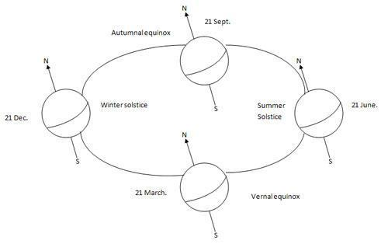

**Hour Angle**

The Hour Angle is the angular distance that the earth has rotated ina day. It is equal to 15 degrees multiplied by the number of hours from local solar noon. This is based on the nominal time, 24 hours, required for the earth to rotate once i.e. 360 degrees .Solar hour angle is zero when sun is straight over head, negative before noon, and positive after noon.(here noon means 12.00 hour)

**Solar Altitude (**θ**z)-**

The solar altitude is the vertical angle between thehorizontal and the line connecting to the sun. At sunset/sunrise altitude is 0 and is 90 degrees when the sun is at the zenith. The altitude relates to the latitude of the site, the declination angle and the hour angle.

**Solar Azimuth (**θ*A*)**-**

The azimuth angle is the angle within the horizontal planemeasured from true South or North. The azimuth angle is measured clockwisefrom the zero azimuth. For example, if you're in the Northern Hemisphere and thezero azimuth is set to south, the azimuth angle value will be negative before solar

**2.2INSOLATION**

Insolation is a measure of solar radiation energy received on a given surface area and recorded during a given time. It is also called solar irradiation and expressed as hourly irradiation if recorded during an hour, daily irradiation if recorded during a day, for example. The unit recommended by the World Meteorological Organization is MJ/ (megajoules per square meter) or J/cm (joules per square centimeter).Practitioners in the business of solar energy mouse the unit Wh/m2 (watt-hours per square meter). If this energy is divided by therecording time in hours, it is then a density of power called irradiance, expressed in W/m2(watts per square meter). Over the course of a year the average solarradiation arriving at the top of the Earth's atmosphere at any point in time is

Roughly 1366 watts per square meter. The Sun's rays are attenuated as they pass through the atmosphere, thus reducing the irradiance at the Earth's surface to approximately 1000W m-2for a surface perpendicular to the Sun's rays at sealevel on a clear day. The insolation of the sun can also be expressed in Suns, where one Sun equals 1000 W/m

**2.3PROJECTION EFFECT**

The insolation into a surface is largest when the surface directly faces theSun. As the angle increases between the direction at a right angle to the surface and the direction of the rays of sunlight, the insolation is reduced in proportion to cosine of the angle; see effect of sun angle on climate.

This 'projection effect' is the main reason why the Polar Regions are much colder than equatorial regions on Earth. On an annual average the poles receive less insolation than does the equator, because at the poles the Earth's surface are angled away from the Sun.

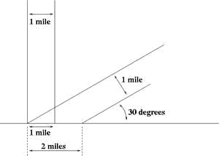

One beam one mile wide shines on the ground at a 90° angle, and another at a 30° angle. The one at a shallower angle distributes the same amount of light energy over twice as much area.

**2.4 WORKING OF PHOTOVOLTAICS**

Photovoltaic are the direct conversion of light into electricity at the atomic level. Some materials exhibit a property known as the photoelectric effect that causes them to absorb photons of light and release electrons. When these free electrons are captured, electric current results that can be used as electricity.A solar cell (also called photovoltaic cell or photoelectric cell) is a solidstate electrical device that converts the energy of light directly into electricity by the photovoltaic effect. Crystalline silicon PV cells are the most common photovoltaic cells in use today.A number of solar cells electrically connected to each other and mounted in a support structure or frame are called a photovoltaic module. Modules are designed to supply electricity at a certain voltage, such as a common 12 volts system. The current produced is directly dependent on how much light strikes the19 module. Multiple modules can be wired together to form an array. In general, the larger the area of a module or array, the more electricity will be produced. Photovoltaic modules and arrays produce direct-current (DC) electricity. They can be connected in both series and parallel electrical arrangements to produce any required voltage and current combination.

**CHAPTER-3**

**3.1INTRODUCTION SOLAR TRACKER**

Solar Tracker is a Device which follows themovement of the sun as it rotates fromthe east to the west every day. The main function of all tracking systems is to provide one or two degrees of freedom in movement. Trackers are used to keep solar collectors/solar panels oriented directly towards the sun as it moves through the sky every day. Using solar trackers increases the amount of solar energy which is received by the solar energy collector and improves the energy output of the heat/electricity which is generated. Solar trackers can increase the output of solar panels by 20-30% which improves the economics of the solar panel project.

**3.3TYPES OF SOLAR TRACKERS**

**PASSIVE TRACKING SYSTEMS**

The passive tracking system realizes the movement of the system by utilizing a low boiling point liquid. This liquid is vaporized by the added heat of the sun and the center of mass is shifted leading to that the system finds the new equilibrium position.

**ACTIVE TRACKING SYSTEMS**

The two basic types of active solar tracker are single-axis and double-axis.

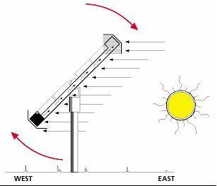

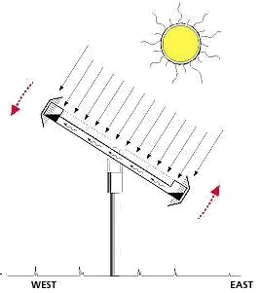

Figure 2.5: Passive tracking system

**Single axistracker**

The single axis tracking systems realizes the movement of either elevation or azimuth for a solar power system. Which one of these movements is desired, depends on the technology used on the tracker as well as the space that it is mounted on. For example the parabolic through systems utilize the azimuthally tracking whereas the many rooftop PV-systems utilize elevation tracking because of the lack of space. A single-axis tracker can only pivot in one plane – either horizontally or vertically. This makes it less complicated and generally cheaper than a two-axis tracker, but also less effective at harvesting the total solar energy available at a site. Trackers use motors and gear trains to direct the tracker as commanded by a controller responding to the solar direction. Since the motors

consume energy, one wants to use them only as necessary.Single axis trackers have one degree of freedom that acts as an axis ofrotation. There are several common implementations of single axis trackers.These include horizontal single axis trackers (HSAT) and vertical single axistrackers (VSAT)A horizontal-axis tracker consists of a long horizontal tube to which solarmodules are attached. The tube is aligned in a north-south direction, is supportedon bearings mounted o n pylons or frames, and rotates slowly on its axis to followthe sun's motion across the sky. This kind of tracker is most effective at equatoriallatitudes where the sun is more or less overhead at noon. In general, it is effectivewherever the solar path is high in the sky for substantial parts of the year, but forthis very reason, does not perform well at higher latitudes. For higher latitude, avertical-axis tracker is better suited. This works well wherever the sun is typicallylower in the sky and, at least in the summer months, the days are long.

**Dual Axis Trackers**

Dual axis trackers as shown in the figure 2.6 have two degrees of freedomthat act as axes of rotation. Double-axis solar trackers, as the same suggest, can rotate simultaneously in horizontal and vertical directions, and s o are able to point exactly at the sun at all times in any location.Dual axis tracking systems realize movement both along the elevation- andazimuthally axes. These tracking systems naturally provide the best performance,

given that the components have high enough accuracy as well.

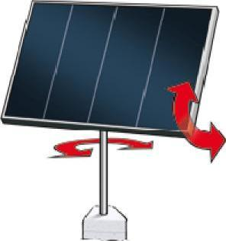

Fig2.6 Dual axis solar tracker

***CHAPTER-4***

**DESIGN OF SOLAR TRACKER**

**TRACKER DESIGN**

A solar tracker is a device that orient photovoltaic array toward the sun. In flat-panel photovoltaic (PV) applications trackers are used to minimize the angle of incidence between the incoming light and a photovoltaic panel. This increases the amount of energy produced by the photovoltaic array.Here we can use azimuth-altitude dual axis trackers (AADAT). Dual axistrackers extract the maximum solar energy levels due to their ability to follow the sun vertically and horizontally. No matter where the sun is in the sky, dual axis trackers are able to angle themselves to be in direction toward the sun.

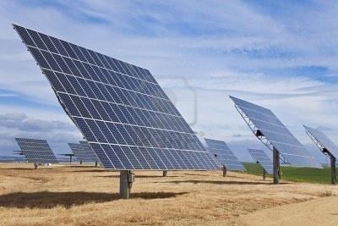Fig. 3.1 Setup of a squared solar pane

l

The Fig. 3.1 shows a setup of a squared solar panel with two degrees of freedom. Here Two DC motors are used to drive the two rotational degrees of freedom. The motors can mounted directly on the rotation pins of the rotational joints to reduce losses caused by linkages and joints and to avoid using more linkages and mechanisms

**DC MOTOR AND MOTOR DRIVER THEORY**

***Introduction***

The tracking systems would need to consist of two motors, which controlthe position of the array, and a control circuit (either analog or digital) to direct these motors. The following sections discuss some possible types of motors thatcould be used for this type of application.

***DC Motor***

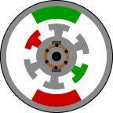

Figure 3.2: Inner Workings of a DC Motor

Figure 3.2 shows the inner workings of a basic DC motor. The outsidesection of the motor is the stator (stationary part), while the inside section is therotor (rotating part).The stator is comprised of two (or more) permanent magnetpole pairs, while the rotor is comprised of windings that are connected to mechanicalcommutator. The opposite polarities of the energized winding and the stator magnet attract each other. When this occurs the will rotate unitperfect alignment with the stator is achieved. When the rotor reaches alignment, the brushes

Motor will be reacted according to the move across the commutator contacts (middle section of rotor) anenergies the next winding. There are two other types of DC motors: series wound and shunt wound. These motors also use a similar rotor with brushes and a commutator. However, the stator uses windings instead of permanent magnets. The basic principle is still same. A series wound DC motor has the stator windings in series with the rotor. A shunt wound DC motor has the stator windings in parallel with the rotor winding.

**DC Servomotors**

By itself the standard DC motor is not an acceptable method of controlling asun tracking array. This is due to the fact that DC motors are free spinning andsubsequently difficult to position accurately. Even if the timing for starting and stopping the motor is correctly achieved, the armature does not stopimmediately. DC motors have a very gradual acceleration and deceleration curves,therefore stabilization is slow. Adding gearing to the motor will help to reduce thisproblem, but overshoot is still present and will throw off the anticipated stopposition. The only way to effectively use a DC motor for precise positioning is to usea servo .The servomotor is actually an assembly of four things: a normal DC motor, a gearreduction unit, a position-sensing device (usually a potentiometer), and a controlcircuit. The function of the servo is to receive a control signal that represents a desired output position of the servo shaft, and apply power to its DC motor untilits shaft turns to that position.

It uses the position-sensing device to determine the rotational position of the shaft, so it knows which way the motor must turn tomove the shaft to the command position. The solar panel that attached to thedirection of the motor.

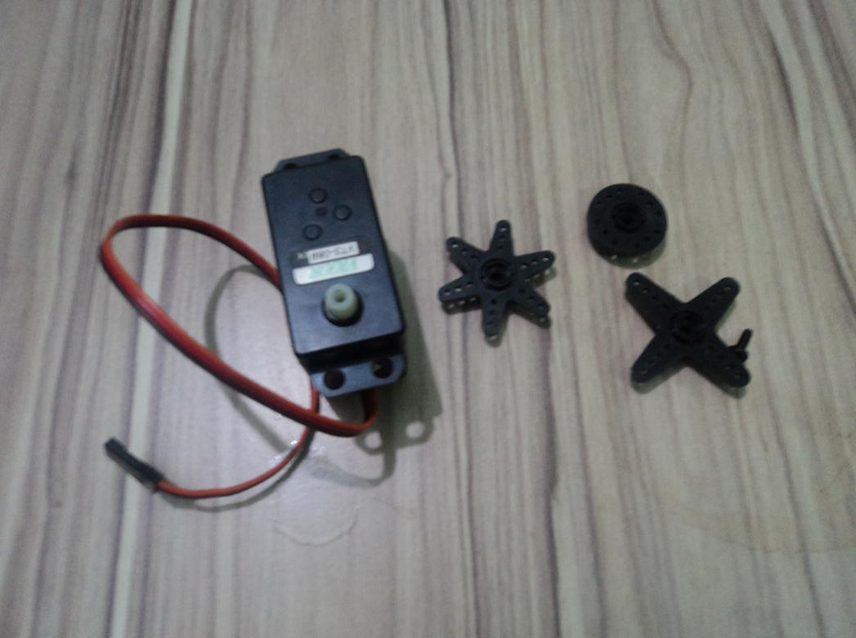

**KINEMATICS**

Earth receives energy of 1000w/m2which means we can generate 1000 watts ofenergy from 1m2 area. If we assume a 10% total efficiency of the photovoltaicpanels, the predicted output power from the panel will be 100 Watt. Although, itis known that there are panels with higher efficiency but it is preferable tocalculate for the least case. Earth complete its one rotation around its axis in 24hours which means that it rotate by 360 degrees in 24 hour or one day. Therefore one hour cover 360/24=150, which means one hour angle =150. The system canbe designed to move discretely to cover the total daily track in desired steps to reduce the operating time. After sunset, the panel can be designed to return backpointing towards the east to collect the sun radiation next morning. This returnprocess can be done in desired time interval. While the maximum needed power isrequired by the motors forms 1% of the output of the panel. So it is feasible torotate the panel using electric motors fed by the output of the panel itself.

**DYNAMICS**

The solar array can be rotated in two directions, horizontal and vertical direction by taking azimuth and inclination angle as reference.Two control techniques can be applied here:

1.Open-loop control technique that depends on calculating the voltage corresponding to the output angles and feeding them into the DC motors (to which our work is concerned).

2.Closed-loop technique which depends mainly on the signals sent by the two *A*31 solar tracking sensors attached at the surface of the panel. The function of thesesensors is to detect the position of the sun and feed the signal back to theelectronic control circuit which in turn sends the signals to the motor to correct

The real position of the panel perpendicular to the sun. Each technique has its advantages and drawbacks, where the open-loop technique is safe and continuous but it needs to keep the motors operating all thetime even when there is no sun in the cloudy days. The closed-loop techniquesaves power because it turns the motors on when the sun is shining only, whilethe system stops working in cloudy periods. The main disadvantage of the closed- loop technique is that it is expensive to be applied that it needs sensors,electronics and control kits. A timer can be used to return the whole systempointing towards the east after sunset to put the panel in a ready position facingthe sun in the next morning. Consider the solar panel drawing shown in Fig. 3.4.

In this drawing, *a* and *b* are the dimensions of the rectangular plate panel, *d* is the perpendicular distance from the center of gravity of the panel to the point of action of the rotating motor. θz and θare the Altitude and Azimuth angles, respectively.

Are the torques produced by the motors around the Altitude and the Azimuth directions respectively. These torques are responsible for the rotation of the two degrees of freedom of the system.

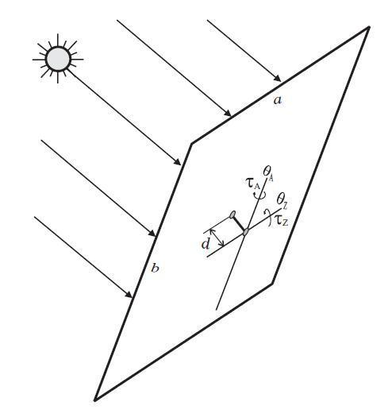

Fig 3.4 Configuration and angles of panel-Zenith angle of the sun

**SYSTEM DESIGN**

The purpose of a solar tracker is to accurately determine the position of thesun. This enables solar panels to interface to the tracker to obtain the maximumsolar radiation.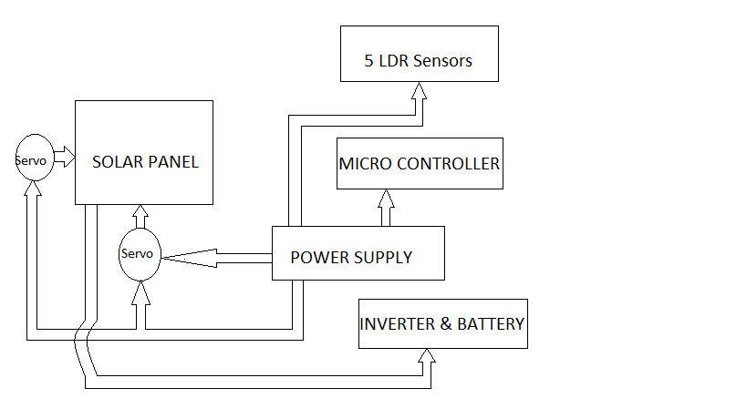

Block Diagram of overall system

The electrical system consists of five LDR sensors which provide feedback to a micro controller. This micro controller processes the sensor input andprovides two PWM signals for the movement of servo motors.This servo motor moves the solar panel towards the higher density of solar light.The entire electrical system is powered by a 12volt source power supply.

Initially five different analog values are obtained from LDR’s, and then they are feed to micro controller. Micro controller gives two different PWM signal for the movement of solar panel through servo motor.

**SENSORS**

We are using Five Light Dependent Resistor’s as a sensor. They sense the higher density area of sun light. The solar panel moves to the high light densityarea through servo motors.

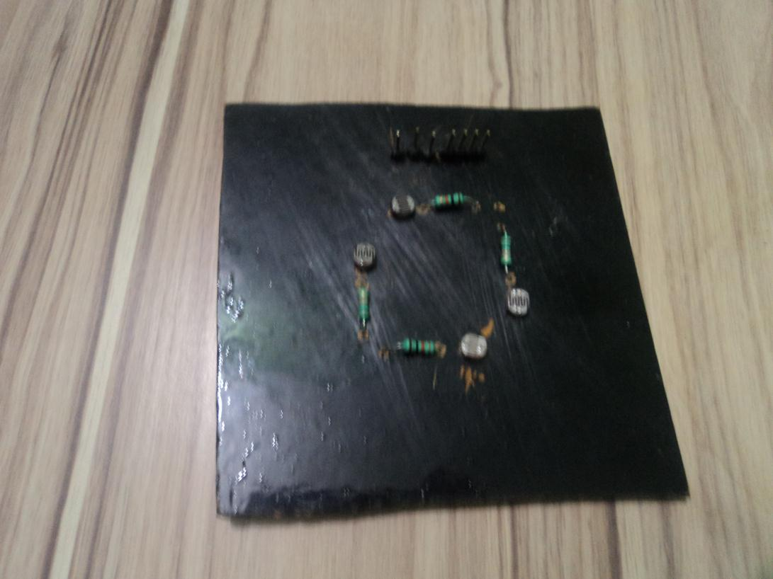

Each LDR is connected to power supply forming a potential devider. Thus any change in light density is proportional to the change in voltage across the LDR’s.

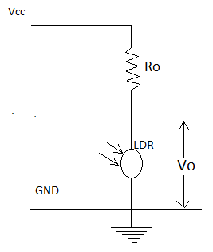

LDR is a passive transducer hence we will use potential divider circuit to obtain corresponding voltage value from the resistance of LDR. LDRs resistance is inversely proportional to the intensity of light falling on it i.e. Higher the intensity or brightness of light the Lower the resistance and vice versa. Interfaces:

**Input(ADC):**

Arduino has an inbuilt 10-bit Analog to Digital converter(ADC), hence it can provide Digital values from 0-1023.(since 2^10=1024). We can also set the ADC reference voltage in arduino, but here we’ll let it use default value. LDR’s has two pins, and to get voltage value from it we use potential divider circuit. In potential divider we get Vout corresponding to resistance of LDR which in turn is a function of light falling on LDR. The higher the intensity of light, lower the35

LDR resistance and hence lower the Output voltage (Vout) and lower the light intensity, higher the LDR resistance and hence higher the Vout.

**Output(PWM):**

Adriano has an 8-bit PWM generator, so we can get up to 256 distinct PWM signal. To drive a servo we need to get a PWM signal from the board, this is usually accomplished using timer function of the microcontroller but arduino makes it very easy. Arduino provides a servo library in which we have to only assign servo angle (0-1800) and the servo rotates by that angle, all the PWM calculations are handled by the servo library and we get a neat PWM signal according to the desired angle.

**MICRO CONTROLLER**

The ATMEGA-168 is a modified Harvard architecture 8-bit RISC single chip microcontroller which was developed by Atmel. It uses on-chip flash memory for program storage, as opposed to one-time programmable ROM, EPROM, or EEPROM used by other microcontrollers at the time.

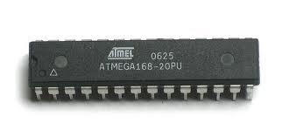**Features:-**

➢Flash : 16KB

➢EEPROM: 1024B

➢SRAM: 512B

➢Clockfreq. : Upto 20MHz

➢Supply voltage: 2.8-5.5v

➢Ext. Interrupt: 24

➢PWM : 6

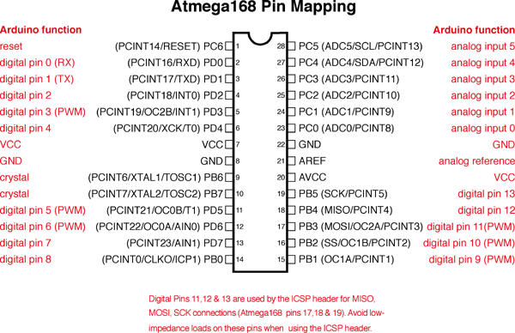

**Pin descriptions**

•**VCC**

Digital supply voltage

•**GND**

Ground

•**Port B (PB7:0) XTAL1/XTAL2/TOSC1/TOSC2** 37

Port B is an 8-bit bi-directional I/O port with internal pull-up resistors (selected for each bit). The Port B output buffers have symmetrical drive characteristics with both high sink and source capability.

As inputs, Port Bpins that are externally pulled low will source Current if the pull-up resistors are activated. The Port B pins are tri-stated when a reset condition becomes active, even if the clock is not running. Depending on the clock selection fuse settings, PB6 can be used as input to the inverting Oscillator amplifier and

Input to the internal clock operating circuit. Depending on the clock selection fuse settings, PB7 can be used as output from the inverting Oscillator amplifier. If the Internal Calibrated RC Oscillator is used as chip clock source, PB7.6 is used as TOSC2.1 input for the Asynchronous Timer/Counter2 if the AS2 bit in ASSR is set.

•**Port C (PC5:0)**

Port C is a 7-bit bi-directional I/O port with internal pull-up resistors (selected for each bit). The PC5...0 output buffers have symmetrical drivecharacteristics with both high sink and source capability. As inputs, Port Cpins that are externally pulled low will source current if the pull-up resistorsare activated. The Port C pins are tri-stated

When a reset condition becomesactive, even if the clock is not running.

•**PC6/RESET**

If the RSTDISBL Fuse is programmed, PC6 is used as an I/O pin. Note that the electrical characteristics of PC6 differ from those of the other pins ofPort C. If the RSTDISBL Fuse is unprogrammed, PC6 is used as a Reset input.A low level on this pin for longer than the minimum pulse length will generatea Reset, even if the clock is not running.

Port D is an 8-bit bi-directional I/O port with internal pull-up resistors (selected for each bit). The Port D output buffers have symmetrical drive characteristics with both high sink and source capability. As inputs, Port D 38 pins that are externally pulled low will source current if the pull-up resistorsare activated. The Port D pins are tri-stated

•**Port D (PD7:0)**

A reset condition becomes active, even if the clock is not running.

•**AVCC**

AVCC is the supply voltage pin for the A/D Converter, PC3:0, and ADC7:6. It should be externally connected to VCC, even if the ADC is notused. If the ADC is used, it should be connected to VCC through a low-passfilter. Note that PC6.4 use digital supply voltage, VCC.

•**AREF**

AREF is the analog reference pin for the A/D Converter.

•**ADC7:6 (TQFP and QFN/MLF package only)**

In the TQFP and QFN/MLF package, ADC7.6 serves as analog inputs to the A/D converter. These pins are powered from the analog supply and serve as 10-bit ADC channels.

**ARDUINO SEVERINO BOARD:**

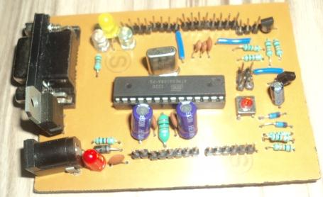

**MY FINAL PROJECT**

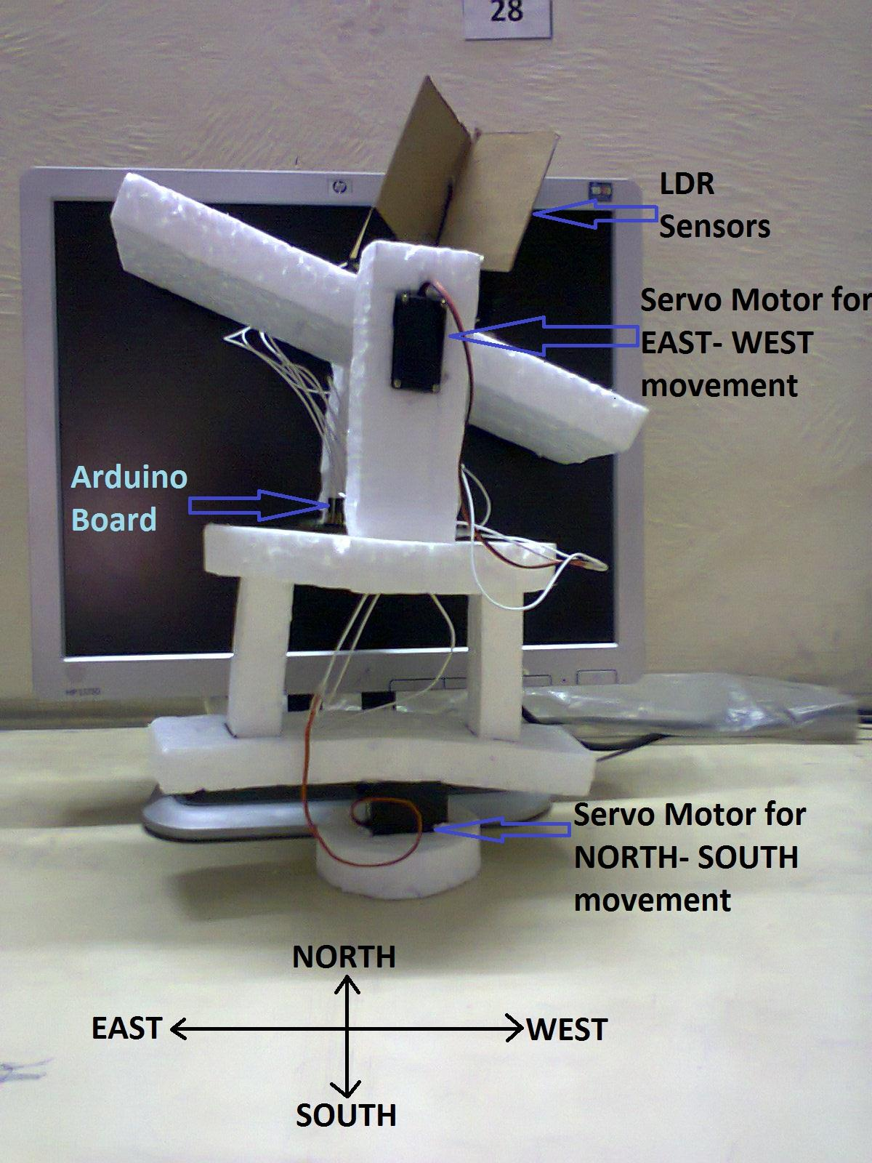

CONCLUSION

Installa solar panel mounts with dual-axis sun tracking capability has been achieved. The work was made possible through the cooperation and involvement of many different parties. Planning and communication skills were essential to ensure that the project went smoothly. There is still room for improvement for this system and it is hoped that further study can be carried out to further develop the system. Improvements can be done to the design of the structure, for example by adding covers for the motors and also improving the design of the sensor holder by making it waterproof. Besides that, improvements can be made to the current method of turning back the frame to its original position, removing the need to manually adjust the limit switches. Also, a detailed study should be carried out to ascertain the percentage increase of electricity yield by using this system to establish whether or not the system is viable.

**REFERENCES**

1. Wettergreen D., Benjamin Shamah, Paul Tompkins, William Whittaker, “Robotic Planetary Exploration by Sun-Synchronous Navigation”, 6the International Symposium on Artificial Intelligence and Robotics & Automation in Space,iSAIRAS 2001, Canadian Space Agency, St-Hubert, Quebec, Canada, June 18-22, 2001.

2. Saravanan C. , Dr .M.A. Panneerselvam, I. William Christopher, “A Novel Low Cost Automatic Solar Tracking System”, International Journal of Computer Applications (0975 – 8887) Volume 31– No.9, October 2011.

3. Hasan A Yousaf, “Design and Implementation of a Fuzzy Logic Computer- Controlled Sun Tracking System”, Proceedings of the IEEE International Symposium on Industrial Electronics, Volume 3, 12-16 July 1999, pp 1030-1034.

4. Tanvir Arafat Khan Md., S.M. ShahrearTanzil, RifatRahman, S M ShafiulAlam, “Design and Construction of an Automatic Solar Tracking System”, presented at 6th International Conference on Electrical and Computer EngineeringICECE 2010, 18-20 December 2010, Dhaka, Bangladesh. 43